Step 1: Go to "My Submissions"
- Log in to your account and go to Account Settings.
- Click on the "My Submissions" tab.
- Find your submission with status "REVISION SUBMITTED" (or the status requiring revision).
- Click the orange "Revise" button on the right side of your submission.
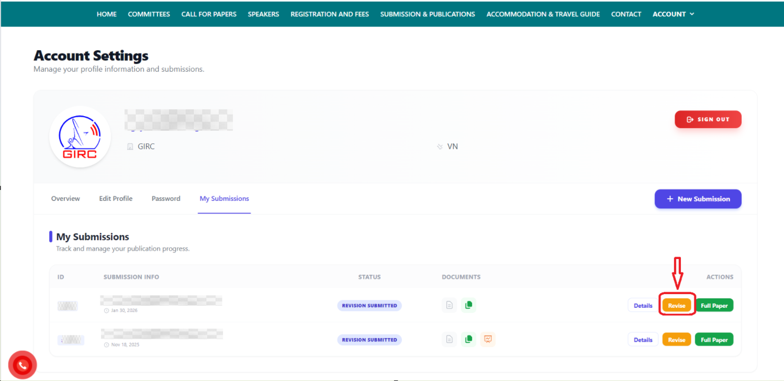

Step 2: Upload your revised documents
On the "Submit Revision" page, you need to upload three required files:
- Revised Manuscript (Clean version) — Click "Upload new version" and select your final, clean revised manuscript (no tracked changes/highlights).
- Revised Manuscript (Tracked changes / Highlighted) — Click "Upload tracked-changes version" and upload the same revised manuscript with tracked changes or highlights showing exactly what was modified.
- Response to Reviewers — Click "Upload response letter" and upload a document that responds point-by-point to the reviewers' comments.
Once all three files are uploaded, click the blue "Submit Revision" button to complete your submission.
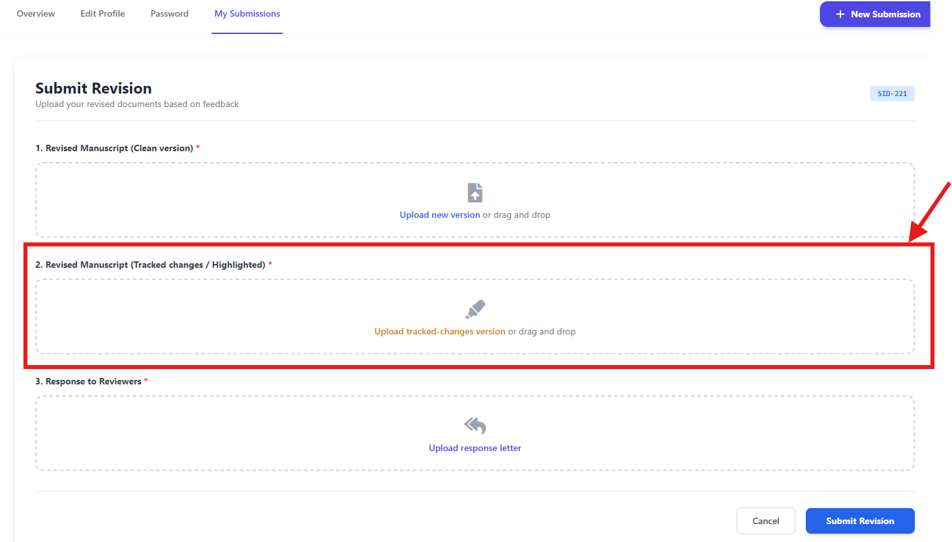
Step 3: Check your submission details
- Go back to "My Submissions" and click "Details" on your submission to view the Submission Details page.
- On the right side, under "Attached Files", you can view/download:
  - Abstract
  - Full Paper
  - Tracked Changes
  - Response Letter
- Note: If you see the message "Editing Locked", it means this submission is currently not open for further edits — only specific submissions allowed by the editorial team can be updated at this stage. Please contact the organizers if you need further changes.
